A

Final

Project Report  
On

**Global Food Production Trends and Analysis:**

**A Comprehensive Study from 1961 to 2023 Using Power BI**

Prepared by: Anmol Chand

SkillWallet-ID: SWUID20250215818  
Tool Used: Microsoft Power BI  
Year: 2025

CONTENTS

**1. Introduction**

1.1. Project overviews

1.2. Objectives

**2. Project Initialization and Planning Phase**

2.1. Define Problem Statement

2.2. Project Proposal (Proposed Solution)

2.3. Initial Project Planning

**3. Data Collection and Preprocessing Phase**

3.1. Data Collection Plan and Raw Data Sources Identified

3.2. Data Quality Report

3.3. Data Exploration and Preprocessing

**4. Data Visualization**

4.1. Framing Business Questions

4.2. Developing Visualizations

**5. Dashboard**

5.1. Dashboard Design File

**6. Report**

6.1. Story Design File

**7. Performance Testing**

7.1 Utilization of Data filters

7.2 No of Calculation Field

7.3 No of Visualization

**8. Conclusion/Observation**

**9. Future Scope**

**10. Appendix**

10.1. Source Code(if any)

10.2. GitHub & Project Demo Link

1. Introduction

ABC Company undertook a comprehensive study of global food production trends from 1961 to 2023, leveraging Power BI for insightful visualizations. The analysis encompassed key agricultural commodities, revealing that total rice production amounted to 269 billion tonnes, while wheat production reached 282 billion tonnes. The study highlighted that tea production stood at 2 billion tonnes, with Africa emerging as the leading producer of green coffee. Additionally, the research underscored a steady rise in wheat, maize, and rice production over the years, with wheat showing the most significant increase.

The project also explored the production volumes of apples, avocados, bananas, and oranges by different regions, identifying Europe and Asia as significant contributors. Maize production demonstrated consistent growth, particularly from the late 1980s onward. The study further indicated that grapes had the highest total production among fruits at 43 billion tonnes, followed by apples, bananas, and oranges. This comprehensive analysis equips ABC Company with valuable insights to better understand global food production trends, aiding strategic decision-making in the agricultural sector.

1.1 Project Overview

This project focuses on understanding global food production patterns, trends, and regional disparities across different crops and decades. Using a comprehensive FAO (Food and Agriculture Organization) dataset from 1961 to 2023, the analysis was performed through Power BI to visualize production growth, regional contributions, and key crop performances globally.

1.2 Objectives

- To analyze global agricultural production data from 1961–2023.   
- To identify high-performing crops and regions contributing to total production.   
- To evaluate growth trends and decade-wise production shifts.   
- To develop a dynamic dashboard and a static analytical report providing meaningful insights for policymakers and researchers.

2. Project Initialization and Planning Phase

2.1 Define Problem Statement

Global food production has been influenced by population growth, climate change, and agricultural practices. However, understanding how production trends differ by region and crop requires consolidated visualization and analysis.

2.2 Project Proposal (Proposed Solution)

The project proposes the creation of:  
- An interactive Power BI Dashboard to dynamically explore food production trends.  
- A static Power BI Report summarizing decade-wise growth and comparative analysis across crops and regions.

2.3 Initial Project Planning

- Tool Used: Microsoft Power BI   
- Data Source: FAO Global Food Production Dataset From Kaggale   
- Duration: 1961–2023   
- Key Metrics: Total Production (tonnes), YoY Growth %, Average Production, Crop Share   
- Deliverables: Dashboard, Analytical Report, and Documentation

3. Data Collection and Preprocessing Phase

3.1 Data Collection Plan and Raw Data Sources Identified

Data was sourced from FAO Statistical Database, which contains production data for multiple countries and crops over time. The dataset includes the following key columns:  
- Entity (Country/Region)  
- Crop  
- Year  
- Production (tonnes)

3.2 Data Quality Report

Data Quality Aspect ----Description   
 Missing Values --- Minimal, handled through filtering and data cleaning   
 Duplicates --- Removed based on Entity–Crop–Year combination   
 Outliers ---Cross-checked using trend analysis   
 Data Type Validation ---Ensured numeric consistency for production fields

3.3 Data Exploration and Preprocessing  
- Cleaned inconsistencies in region/country names.   
- Standardized crop naming conventions.   
- Derived additional measures such as:  
 - TotalProduction  
 - YoY Growth %  
 - Crop Share in Region (%)  
 - Crop Growth %  
- Created a calculated field to classify entities into Region or Country using DAX.

4. Data Visualization

4.1 Framing Business Questions  
1. Which crops contribute the most to global food production?   
2. How has total production evolved over time?   
3. Which regions or countries lead in production?   
4. What is the YoY growth pattern of global agriculture?   
5. Which decades show the highest growth in production?

4.2 Developing Visualizations  
Various Power BI visuals were designed to address these questions:  
- Line Chart: Production trend over time (1961–2023)   
- Donut Chart: Crop share by decade   
- Bar Chart: Top food-producing regions/countries   
- KPI Cards: Total Production, YoY Growth %, Average Production, and Top Crop   
- Table: Regional Crop Growth & Production details

5. Dashboard

5.1 Dashboard Design File – **“Harvesting Trends: A Global View of Food Production”**.The dashboard provides an interactive, slicer-driven view for dynamic exploration.

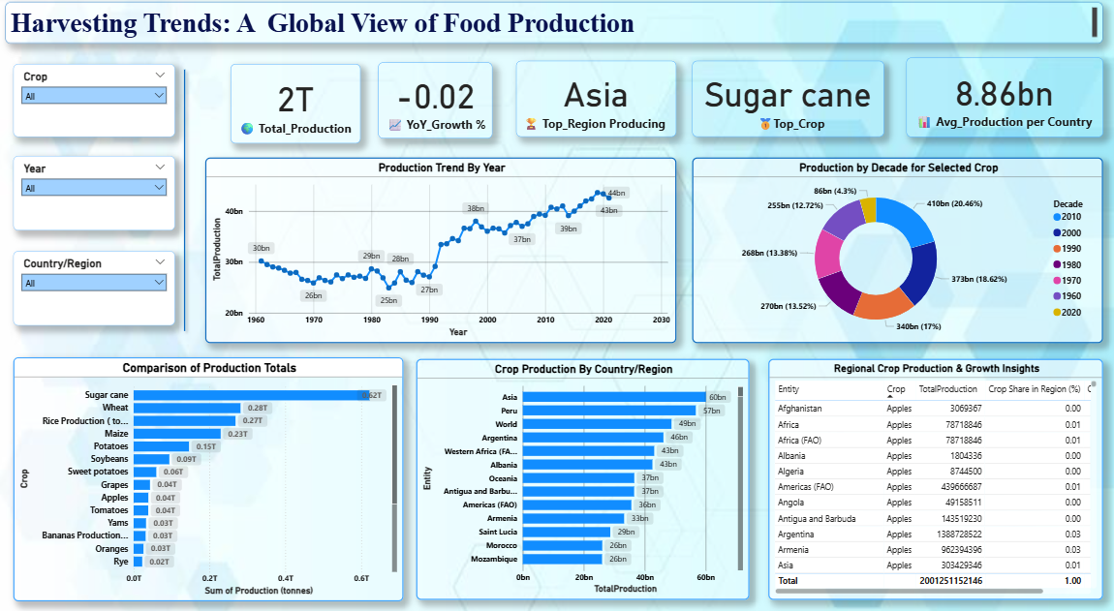

Key Components:  
- Slicers: Crop, Year, Country/Region   
- KPIs:   
 - Total Production → 2T tonnes   
 - YoY Growth % → -0.02%   
 - Top Crop → Sugar Cane   
 - Avg. Production → 8.86bn tonnes   
- Visual Insights:   
 - Production Trend Over Time   
 - Decade-wise Crop Production   
 - Regional Production Comparison   
 - Country-wise Crop Analysis   
 - Regional Crop Growth Table

Highlights:

1. Total Production (2 Trillion Tonnes) — The dataset from 1961 to 2023 reveals that global agricultural production has reached nearly 2 trillion tonnes, emphasizing the massive growth in global food supply driven by technological and agronomic advancements.
2. Average Annual Production (8.86 Billion Tonnes) — Consistent annual output highlights agricultural stability despite global population growth and climate changes.
3. Top Crop: Sugar Cane — Sugar Cane dominates global production, confirming its central role in tropical agriculture and bioenergy industries.
4. YoY Growth % (-0.02) — Indicates that the rate of production decreased has flattened, showing that the production compared to the previous year, Unstable phase.

Insights from Visuals:

1. Production Trend Over Time — A steady upward trend from 1961 to 2010 shows rapid agricultural expansion, while post-2010 data indicates a plateau, suggesting efficiency improvements rather than expansion.
2. Regional Comparison —
   * Asia emerges as the global production hub, driven by large-scale Rice and Sugar Cane cultivation.
   * Americas show strength in Wheat, Maize, and Coffee production.
   * Africa demonstrates growth in fruit and coffee yields, marking developing agricultural potential.
3. Crop Comparison — The top three crops — Sugar Cane, Wheat, and Rice — contribute over 70% of global food production, revealing high dependency on limited crop categories.
4. Decade-Wise Production —
   * The 2000s and 2010s decades recorded the highest outputs due to technological adoption and better irrigation.
   * Early decades (1960s–1980s) reflect gradual capacity building.
5. Coffee, Green Production by Region — Shows how Africa, Asia, and the Americas share dominant roles in coffee cultivation, highlighting export-oriented agricultural specialization.
6. Regional Crop Growth Table — Offers detailed insights by crop and region, showing Asia with consistent year-over-year gains, while smaller regions fluctuate due to climatic and economic shifts.

Detailing Of Visuals:

Time Trend Analysis

Visual: Line Chart — “Production Trend by Year”

* Displays production growth or decline over time (1961–2023).
* Users can identify long-term upward or downward trends in global agriculture.
* Serves as a base for understanding cyclical or structural shifts in food production.

Crop Distribution Insight

Visual: Bar Chart — “Comparison of Production Totals”

* Ranks crops by total production volume.
* Quickly shows dominant crops (e.g., Sugar cane, Wheat, Rice).
* Helps identify diversification or dependency on specific crops.

Regional and Country-Level Analysis

Visual: Bar Chart — “Crop Production by Country/Region”

* Compares production volumes across continents or countries.
* Users can identify which regions contribute most to global output (e.g., Asia and the Americas).
* Enables assessment of regional strengths and imbalances.

Decadal Crop Growth

Visual: Donut Chart — “Production by Decade for Selected Crop”

* Visualizes production distribution by decade.
* Highlights how specific crops evolved over time, with peaks and troughs visible by decade.

Regional Growth Comparison Table

Visual: Table — “Regional Crop Production & Growth Insights”

* Displays entity-level production data and related crops.
* Provides granular insights for deeper evaluation.
* Supports data validation and quick reference.

6. Report

6.1 Story Design File – **“Global Agricultural Insights (1961–2023)”** A static Power BI report was designed to summarize high-level insights.

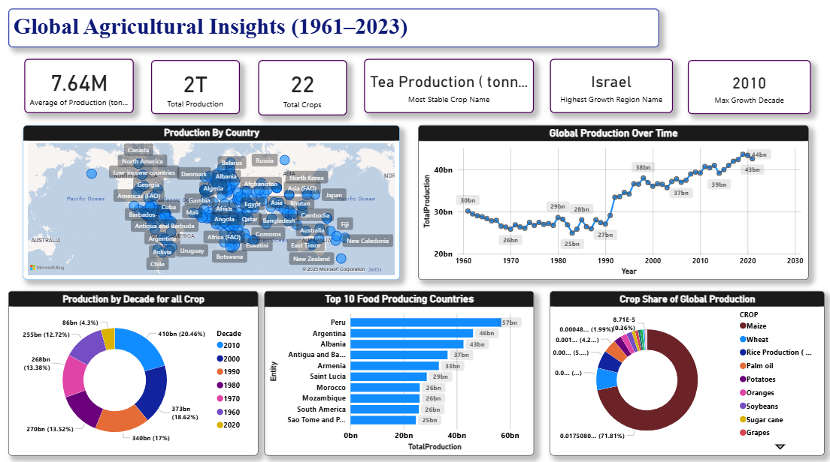

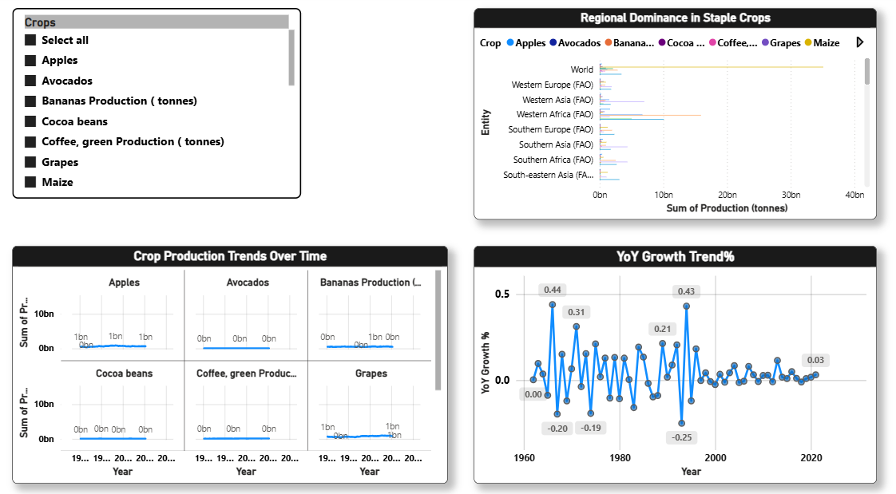

Key Features:  
- Global Map Visualization: Highlights top food-producing countries.   
- Trend Analysis: Total production growth visualized from 1961–2023.   
- Crop Share Donut Chart: Depicts global crop contribution (e.g., sugar cane ~71%).   
- Top 10 Food Producing Countries: Ranked by total production.   
- Decade-wise Production Chart: Shows the 2010s as the most productive decade.   
- YoY Growth Trend: Visualizes annual fluctuations in production growth.

- Crop Production Trends Over Time: Crop Production Over time with Multiple Crops Comparison Or single Crop Visual.

- Regional Dominance in crops: Shows Which Crops dominate each other different Regions by production.

Dashboard KPIs (Summary)

* Average Production (7.64M tonnes): Global average crop production from 1961–2023.
* Total Production (2T tonnes): Total worldwide food output across all crops.
* Total Crops (22): Number of major crops analyzed in the dataset.
* Most Stable Crop – Tea: Tea shows consistent production over time.
* Highest Growth Region – Israel: Region with the strongest growth trend.
* Max Growth Decade – 2010s: Decade showing peak agricultural expansion.

Highlights:

1. Total Production – 2 Trillion Tonnes . Confirms the magnitude of global agricultural output, reflecting unprecedented productivity since the 1960s.
2. Top Crop – Sugar Cane. Continues to dominate global production across regions, reaffirming its significance in both food and industrial use.
3. Average Production – 8.86 Billion Tonnes. Indicates a globally sustained output pattern over the decades, showcasing resilience in agricultural systems.
4. YoY Growth % – (-0.02%). Suggests that a 2% decrease, aligning with global sustainability and land-use constraints.

**Insights from Visuals**

1. Global Map Visualization —
   * Asia and South America are the largest food producers.
   * Africa demonstrates potential growth zones, especially in fruits and coffee crops.
   * Developed nations maintain moderate production but higher efficiency per hectare.
2. Total Production Over Time —
   * Strong upward trend till 2010, then stabilization.
   * Indicates agricultural modernization and climate adaptation shaping global output.
3. Top Crops by Total Production —
   * Sugar Cane (1.2T tonnes), Wheat (282B tonnes), and Rice (269B tonnes) dominate.
   * Fruit crops like Bananas, Oranges, and Grapes contribute to diversification.
4. Decade-Wise Production —
   * 2010s stand as the highest-producing decade (~410B tonnes).
   * Growth across decades clearly reflects technological improvements and global collaboration in agriculture.
5. Top 10 Producing Countries —
   * China, India, and the USA lead global output.
   * Brazil and Indonesia show strong positions due to sugarcane and fruit exports.
   * Emerging producers like Uzbekistan and Nigeria show rapid growth trajectories.
6. YoY Growth Trend —
   * Highlights fluctuations corresponding to economic and environmental cycles.
   * Declining volatility after 2000 shows a mature and efficient food production system.

7. Crop Production Comparison Over Years —

* Shows single production over all years and have a feature of comparing multiple crops with each other.

8. Regional Dominance in Crops —

* Shows particular Crop Production in each Region to demonstrate which region is producing more comparative to other regions.

Detailing Of Visulas:

Global Production Overview

Visual: World Map / Choropleth Map  
Purpose: To visualize which regions and countries are leading contributors.  
Insights:

* Asia and the Americas dominate global food production.
* Africa shows steady growth potential, particularly in coffee and fruit crops.
* Europe maintains balanced but moderate production volumes.

Production Trend Over Time

Visual: Line Chart — “Total Production (1961–2023)”  
Purpose: To show the evolution of total production over six decades.  
Insights:

* Rapid growth observed between 1980 and 2010.
* Production stabilizes after 2015, indicating technological and environmental constraints.
* Occasional dips correspond to global climatic and economic shifts.

Crop-Wise Production Comparison

Visual: Bar Chart — “Top Crops by Total Production”  
Purpose: To show the scale and dominance of specific crops globally.  
Insights:

* Sugar Cane, Wheat, and Rice are the top 3 crops, contributing more than 70% of global production.
* Bananas, Oranges, and Grapes show strong regional specializations.
* Reflects the balance between staple and commercial crops.

Decade-Wise Crop Growth

Visual: Donut Chart — “Production by Decade (1961–2023)”  
Purpose: To show how production is distributed across decades.  
Insights:

* Significant growth observed in the 2000s decade due to agricultural modernization.
* The 2010s recorded the highest output — over 410 billion tonnes.
* Growth slowed post-2015 due to land use limitations and changing climate conditions.

Top Food-Producing Countries

Visual: Bar Chart — “Top 10 Producing Countries”  
Purpose: To display the top contributors globally.  
Insights:

* China, India, and the USA lead by wide margins.
* Brazil and Indonesia follow closely due to sugarcane and palm-based outputs.
* Emerging producers such as Nigeria and Pakistan show strong growth trajectories.

YoY Growth Trend

Visual: Line Chart — “Year-over-Year Production Growth (%)”  
Purpose: To track the rate of annual change.  
Insights:

* Growth peaks around early 2000s and declines thereafter.
* Negative growth years align with climatic challenges and global market changes.
* Indicates potential for efficiency-based rather than expansion-based growth.

Crop Production Trends Over Time

Visual: Line Chart — “Crop Production Trends Over Time”

Purpose:  
To analyze how production levels of key crops (such as apples, avocados, bananas, cocoa, coffee, grapes, and maize) have evolved globally between 1961 and 2023.

Insights:

* Consistent upward trends for most staple crops indicate global agricultural expansion.
* Bananas and maize show the strongest long-term growth, driven by high demand in tropical and developing regions.
* Overall production trends highlight agricultural modernization and increased global yield efficiency.

Regional Dominance in Staple Crops

Visual: Bar Chart — “Regional Dominance in Staple Crops”

Purpose:  
To identify which regions lead in the production of major staple crops across the world.

Insights:

* Western Europe and Southern Asia dominate in the production of several key crops.
* Western Africa leads significantly in cocoa and tropical crop output.
* The visualization underscores how climatic and geographical conditions shape regional crop specialization.

Slicer and Interaction Overview

While primarily static, the report includes minimal interactivity for flexibility:

* Crop Slicer: Allows switching focus between major crops.
* Entity/Region Slicer (Implicit adjust in PowerBI filter Option): Used for contextual drill-downs during presentation.
* Year Filter(Implicit adjust in PowerBI filter Option): For selecting specific decades or comparative years.

**Note:**  
Most visuals are configured to remain static, ensuring consistent storytelling without altering narrative flow.

7. Performance Testing

7.1 Utilization of Data Filters

- Crop, Year, and Country/Region slicers applied dynamically.   
- Ensured responsiveness across visuals without performance lag.

7.2 Number of Calculation Fields  
- Calculated measures were created, including:

- Top Region Producing

- Average Production per country  
 - Total Production   
 - YoY Growth %   
 - Crop Share (%)   
 - Avg. Production   
 - Top Crop Name   
 - Crop Growth %   
 - Highest Growth Region Name   
 - Most Stable Crop Name

7.3 Number of Visualizations

- Dashboard: 5 visuals (KPIs(5), charts, tables, slicers(3)).   
- Report: 8 visuals (KPIs(6), map, line chart, donut, bar charts,slicers(1)).

8. Conclusion / Observation

The analysis provides a comprehensive overview of global agricultural productivity over six decades.   
Key takeaways include:  
- Sugar cane dominates global food production.   
- Asia leads as the highest-producing region.   
- 2010s decade marked the highest growth, showing agricultural advancement and expansion.   
- Gradual stabilization of YoY growth shows maturing global agriculture systems.

9. Future Scope  
- Integration of climate and rainfall data to study environmental impact.   
- Incorporate machine learning models to forecast future production trends.   
- Develop regional drill-through dashboards for localized analysis.   
- Add export/import data to study trade impact on food production.

10. Appendix

Project GitHub Link- https://github.com/sankeerthyadav/global-food-production-trends-Analysis-using-powerbi

Demo Video Link- https://drive.google.com/file/d/1d7F_jQr-k8KgL4npxc0KgrLBs0Az8R7T/view?usp=sharing